BECA / Huson / 10.3 Geometry Name:

7 December 2018

**Regents Practice: Factoring & Solving Quadratics**

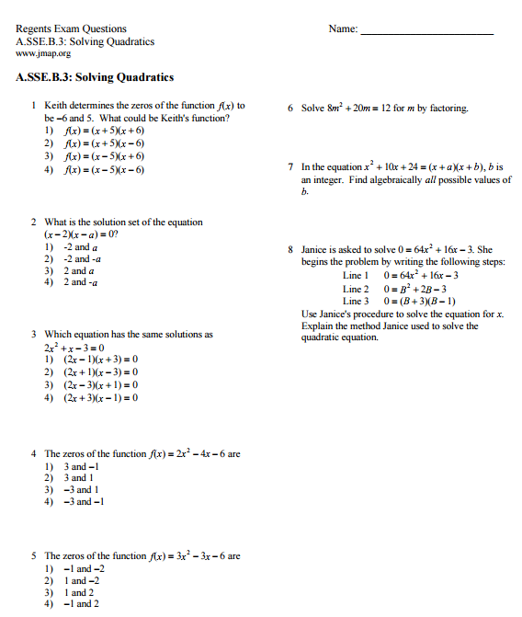

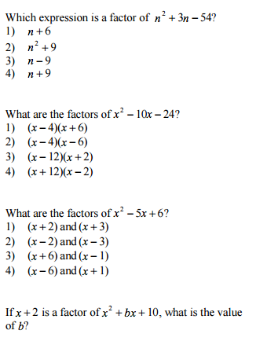

6.

7.

8.

9.



10.